Brett Worley

CEG-2400-01

**Lab FOUR – AZURE SETUP – Network Media - 20 POINTS**

Prepare and submit to Lab 4 dropbox in PILOT.WRIGHT.EDU

**READ THIS ENTIRE LAB (BEFORE) YOU BEGIN**

**SERIOUSLY – I know my audience, stop clicking and READ!**

1. Make sure you have the AZURE activation code provided for your 6 Month (180 Day) Azure for academics account.
2. Visit - <http://www.microsoftazurepass.com/> - and activate your account
3. Watch at LEAST the two videos from the Azure 2.0 training course provided from atomic learning. You can access Atomic Learning from Wright State by visiting this link: <https://cas.wright.edu/cas/login?service=https://secure2.atomiclearning.com/sso/cas/wright>
   1. Click the “SEARCH” tab in the blue bar across the top of the screen. Then in the search box inside Atomic Learning enter Azure and click the link for the Azure / Azure 2.0 training.
   2. View at LEAST section ONE and TWO of this series to familiarize yourself with Azure and the process of creating a virtual machine.
4. If you want more instructional materials for Microsoft Products including Azure, here is the resource provided by Microsoft: <http://www.microsoftvirtualacademy.com/>
5. AZURE is compatible with several browsers, but Internet Explorer 11, EDGE Browser or the latest version of Chrome / Chromium are recommended.
6. Once you have activated your account, watched the two Atomic Learning segments, and gotten logged into <http://www.azure.com/> (**CLICK THE LINK AT TOP RIGHT THAT SAYS PORTAL**) then you are ALMOST FINISHED.
7. CREATE AT LEAST ONE NEW VIRTUAL MACHINE. Below I have put a few breadcrumbs to help you along the path, but the videos should provide you with sufficient understanding to perform this task.
8. On the Left side of the AZURE PORTAL Click on VIRTUAL MACHINES (should be third item down the list).
9. CLICK the +NEW button in the bottom left corner.
10. NOW click COMPUTE then VIRTUAL MACHINE and then FROM GALLERY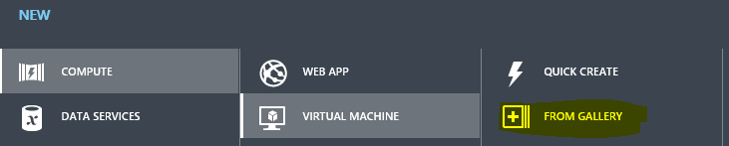
11. In the list of server options CLICK MICROSOFT and the CLICK WINDOWS SERVERS and then in the list to the right of that select WINDOWS SERVER 2016 Technical Preview 3. (CLICK ON IT TO HIGHLIGHT IT).



* 1. This Server choice is being made for this lab as it “should not” count against your quota and usage and will allow you to create some additional servers that do count if you wish to do so – (HIGHLY RECOMMENDED).

1. Click the Right arrow in a circle down in the lower right corner.

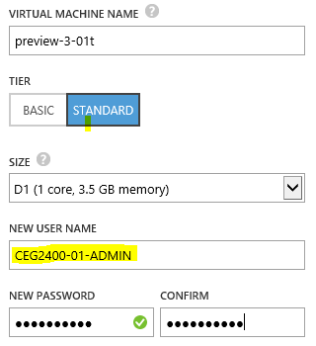

1. **VERY, VERY, VERY IMPORTANT** – Set the username and password to THESE EXACT CREDENTIALS ( I will be using them to login to your servers)
   1. **NEW USER NAME: CEG2400-01-ADMIN**
   2. **PASSWOD: CEG2400-01 (ALL CAPS)**
2. Click the Right arrow in a circle down in the lower right corner.
3. SET YOUR TIMEZONE to EAST US and leave the rest of the setting the same. Then click the RIGHT ARROW in the CIRCLE Again.

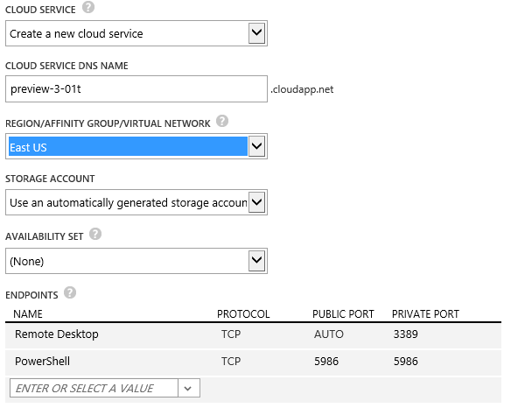

1. MAKE SURE install the VM AGENT is checked and ADD the Microsoft Endpoint Protection by checking the box next to that item.

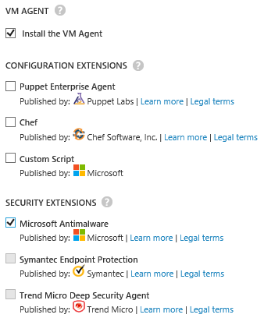

1. CLICK THE CHECKMARK IN THE CIRCLE IN THE LOWER RIGHT HAND CORNER!!
2. If you are curious what is happening once you click that checkmark, then click the little green bars in the bottom left corner of the main portal and then click the DETAILS link that pops up. BUILDING THE SERVER… PLEASE WAIT… A WHILE!

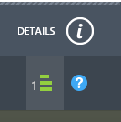

1. **THE FINAL STEPS:**
   1. **MAKE SURE THE SERVER IS POWERED ON.**
   2. **LOGIN TO the SERVER**
      1. **NEW USER NAME: CEG2400-01-ADMIN**
      2. **PASSWOD: CEG2400-01 (ALL CAPS)**
      3. **HINT: Look for the CONNECT BUTTON at the bottom of the screen listing your Virtual machines.**
      4. **MAKE SURE YOU TYPE THIS EXACT THING for the USERNAME: .\CEG2400-01-ADMIN – (that is a period and BACK SLASH)**
   3. **POVIDE THESE TWO PIECES OF DATA**
      1. **WHAT IS THE SERVER NAME: PREVIEW-025WIN**
      2. **WHAT IS THE SERVER IP ADDRESS: 100.76.170.92 is what I found inside of the machine, but from the dashboard of the Azure portal, it lists a PUBLIC VIRTUAL IP (VIP) ADDRESS of 137.116.77.174**